Software Design Document

QsARC: An accreditation Software for UTB

Juan H. Nava

11/12/2014

Revision 1.1

Prepared for

Software Engineering

Instructor: MK Quweider, Ph.D.

Fall 2014

**Table of Contents**

1. Introduction 1

1.1 Purpose 1

1.2 Scope 1

1.3 Definitions, Acronyms, and Abbreviations. 1

1.4 customer. 1

2. Design Overview 2

2.1 description of problem 2

2.2 system operation 2

2.2.1 store acreditation data 2

2.2.2 Sequence Diagram store data 2

3.Interface 2

4.project timeline 2

# 1. Introduction

## 1.1 Purpose

The purpose of the SDD document is to describe the implementation of the software: QsARC: An accreditation Software for UTB describe in The University academic repository requirements . The Accreditation Software for UTB is designed to store accreditation data ans generate requested reports.

## 1.2 Scope

This document describes the implementation details of the software: QsARC: An accreditation Software for UTB. The software consists of two major functions. First to store accreditation data and the second to generates reports.This report will not include testing details in its initial stage.

## 1.3 Definitions, Acronyms, and Abbreviations

|  |  |
| --- | --- |
| Term | Definition |
| Database | Data Structure that stores information |
| GUI | Graphical User Interface |
| HTML | Hypertext Markup Language |
| IDE | Interactive Development Environment |
| IEEE | Institute of Electrical and Electronics Engineer |
| PDF | Portable Document File |
| POS | Program of Study |
| SRS | Software Requirements Specification |
| TXT | Text |
| UTB | University of Texas at Brownsville |
| XML | Extensible Markup Language |

## 1.4 Customer

University of Texas at Brownsville, Departments - The end user of the software developed for this project.

# 2. Design Overview

## 2.1 Description of Problem.

The customer has requested the development of a software that automate the process to store accreditation Data and to generate reports of the information store by the departments.

## 2.2 System Operation.

2.2.1 Store Accreditation Data

2.2.2 Sequence Diagram Store Data

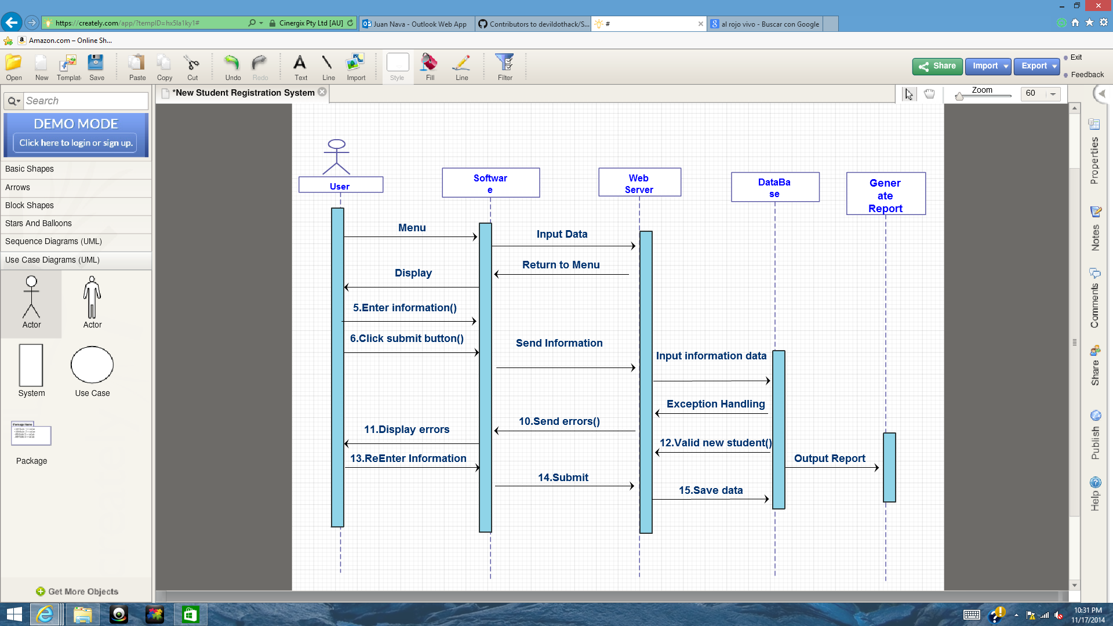

# 3. Interface

The Interface will include and intyerface that will display a wizard panel to select teh different options with buttons and textboxs. This options will store data, read data and extract data as reports.

# 4. Project Timeline